**Object Test Case: Water Bottle**

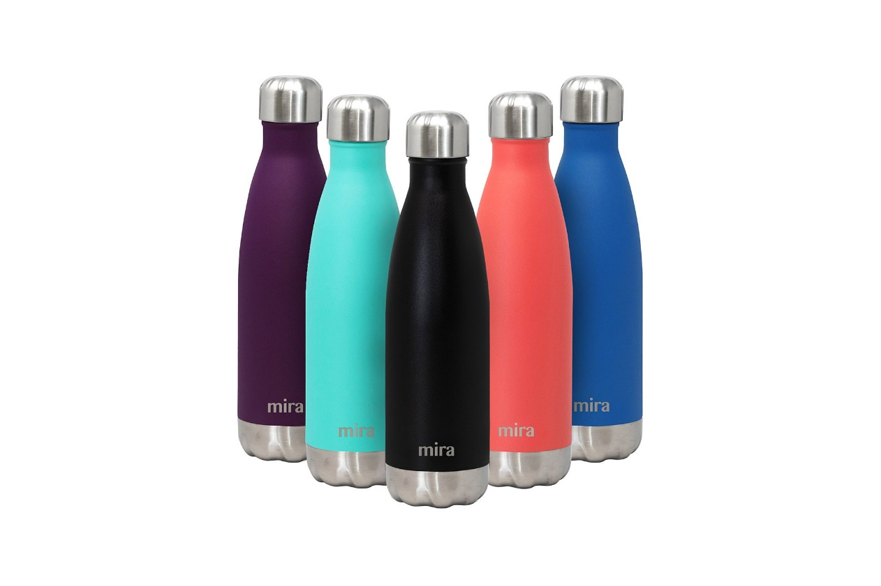

1. Verify Brand Name and Position
2. User-Friendly Features
3. Check Water Bottle Height
4. Inspect Body Shape
5. Assess Body Color
6. Check Cap Height and Shape
7. Verify Water Volume Capacity
8. Examine End Cap Shape (if any)
9. Check Water Bottle Weight
10. Check Material
11. Check Leak-proof
12. Leak Resistance Under Pressure
13. Check Lid or Cap Functionality
14. Taste and Odor
15. Temperature Insulation
16. Compatibility with Beverage Types
17. **Check Bottle Stability**
18. **Check Bottle Transparency (if applicable)**
19. **Check Ease of Holding**
20. Cleaning Evaluation
21. Environmental Impact
22. Pouring Water
23. Drinking from the Bottle

**Detailed Test Case:**

1. **Test Case 1: Verify Brand Name and Position**
   * Description: Confirm that the brand name is clearly visible on the water bottle and positioned in a prominent and easily noticeable location.
   * Steps: Visually inspect the bottle.
   * Expected Result: The brand name is clearly visible and positioned as described.
2. **Test Case 2: User-Friendly Features**
   * Description: Verify the functionality of any additional features such as carrying handles, integrated straws, or built-in filters.
   * Steps: Inspect and test any additional features.
   * Expected Result: All additional features should function as intended.
3. **Test Case 3: Check Water Bottle Height**
   * Description: Measure and verify that the height of the water bottle matches the specified dimensions in the product description.
   * Steps: Use a measuring tool to measure the height of the bottle.
   * Expected Result: The height of the bottle matches the product specification.
4. **Test Case 4: Inspect Body Shape**
   * Description: Examine the water bottle to ensure it has the intended body shape, whether it’s cylindrical, tapered, or any other design as described.
   * Steps: Visually inspect the shape of the bottle.
   * Expected Result: The shape of the bottle matches the product specification.
5. **Test Case 5: Assess Body Color**
   * Description: Confirm that the body color of the water bottle matches the advertised color and check for consistency in color throughout the entire body.
   * Steps: Visually inspect the color of the bottle.
   * Expected Result: The color of the bottle matches the product specification and is consistent throughout.
6. **Test Case 6: Check Cap Height and Shape**
   * Description: Measure the height of the bottle cap and inspect its shape to ensure it matches the intended design, whether it’s a screw-on cap, flip cap, or any other type.
   * Steps: Use a measuring tool to measure the height of the cap and visually inspect its shape.
   * Expected Result: The height and shape of the cap match the product specification.
7. **Test Case 7: Verify Water Volume Capacity**
   * Description: Fill the water bottle to its maximum capacity and measure the volume to confirm it matches the specified capacity.
   * Steps: Fill the bottle with a measured amount of water equal to its stated capacity.
   * Expected Result: The bottle should be able to hold the specified amount of water without overflowing.
8. **Test Case 8: Examine End Cap Shape (if any)**
   * Description: Inspect the shape and design of the end cap (bottom) of the water bottle, ensuring it aligns with the product description.
   * Steps: Visually inspect the end cap of the bottle.
   * Expected Result: The shape and design of the end cap match the product specification.
9. **Test Case 9: Check Water Bottle Weight**
   * Description: Weigh the water bottle to verify that it matches the specified weight or falls within an acceptable tolerance range.
   * Steps: Use a weighing scale to measure the weight of the bottle.
   * Expected Result: The weight of the bottle matches or is within an acceptable range of the product specification.
10. **Test Case 10: Check Material**
    * Description: Verify that the water bottle is made of a specified material (e.g., plastic, glass, stainless steel). Also, check is it safe for health.
    * Steps: Visually inspect and feel material texture
    * Expected Result: The material should match with product specification.
11. **Test Case 11: Check Leak-proof**
    * Description: Verify that when filled with water and closed properly, no leakage occurs.
    * Steps: Fill the bottle with water, close it, and then turn it upside down or shake it.
    * Expected Result: No water should leak from the bottle.
12. **Test Case 12: Leak Resistance Under Pressure**
    * Description: Apply external pressure to the filled bottle and check for any signs of leakage.
    * Steps: Fill the bottle with water, close it, and apply external pressure.
    * Expected Result: No water should leak from the bottle when pressure is applied.
13. **Test Case 13: Check Lid or Cap Functionality**
    * Description: Verify that the lid or cap of the water bottle opens and closes correctly.
    * Steps: Open and close the lid multiple times.
    * Expected Result: The lid should open and close smoothly without any issues.
14. **Test Case 14: Taste and Odor**
    * Description: Ensure that the water or liquid stored in the bottle does not absorb or impart any taste or odor.
    * Steps: Fill the bottle with water, let it sit for a few hours, then taste the water.
    * Expected Result: The water should not have any additional taste or odor.
15. **Test Case 15: Temperature Insulation**
    * Description: Test if the bottle can maintain the temperature of the liquid, both hot and cold, for a reasonable period.
    * Steps: Fill the bottle with a hot or cold liquid, wait for a specified time, then check the temperature of the liquid.
    * Expected Result: The bottle should maintain the temperature of the liquid for a reasonable period.
16. **Test Case 16: Compatibility with Beverage Types**
    * Description: Test the bottle with different types of liquids, including water, juice, and carbonated beverages to ensure it can contain them without issues.
    * Steps: Fill and empty the bottle with different types of liquids and check for any issues.
    * Expected Result: The bottle should be able to contain different types of liquids without issues.
17. **Test Case 17: Check Bottle Stability**
    * Description: Verify that the water bottle is stable when placed on a flat surface.
    * Steps: Place the empty and filled bottle on different flat surfaces.
    * Expected Result: The bottle should not tip over easily.
18. **Test Case 18: Check Bottle Transparency (if applicable)**
    * Description: If the bottle is supposed to be transparent or semi-transparent, verify that the liquid inside is visible.
    * Steps: Fill the bottle with colored liquid and observe from outside.
    * Expected Result: The liquid inside should be visible as per the transparency level mentioned in the product specification.
19. **Test Case 19: Check Ease of Holding**
    * Description: Verify that the water bottle is easy to hold and does not slip from the hand.
    * Steps: Hold the bottle in hand and simulate drinking action.
    * Expected Result: The bottle should be comfortable to hold and should not slip from the hand.
20. **Test Case 20: Cleaning Evaluation**
    * Description: Verify that the water bottle is cleaned and can be clean easily.
    * Steps: Have a close look to detect any scratch. Try to clean the bottle with a standard cleaning method (e.g., dish soap and warm water).
    * Expected Result: The bottle should look fresh without any scratch and the bottle should be easy to clean and not retain any residue or smell after cleaning.
21. **Test Case 21: Environmental Impact**
    * Description: Assess the bottle’s environmental impact, including its recyclability and use of eco-friendly materials.
    * Steps: Review product materials and manufacturing processes information.
    * Expected Result: The bottle should be made from recyclable and eco-friendly materials.
22. **Test Case 22: Pouring Water**
    * Description: Check if water can be poured from the bottle smoothly without any leakage. Ensure that the water flow can be easily controlled.
    * Steps: Fill the bottle with water and pour it into another container.
    * Expected Result: Water should be poured smoothly without any leakage and the flow should be easily controlled.
23. **Test Case 23: Drinking from the Bottle**
    * Description: Verify that the bottle’s spout or opening allows for easy drinking without spillage. Ensure that the bottle can be drunk from at different angles without leakage.
    * Steps: Drink water from the bottle at different angles.
    * Expected Result: It should be easy to drink from the bottle without spillage or leakage at different angles.